**Exercise 4: Functions**

**Scenario 1:** Calculate the age of customers for eligibility checks.

**Question:** Write a function CalculateAge that takes a customer's date of birth as input and returns their age in years.

CREATE OR REPLACE FUNCTION CalculateAge (

p_dob DATE

) RETURN NUMBER

IS

v_age NUMBER;

BEGIN

-- Calculate the number of full years between current date and date of birth

v_age := FLOOR(MONTHS_BETWEEN(SYSDATE, p_dob) / 12);

RETURN v_age;

END;

/

DECLARE

v_dob DATE := TO_DATE('1985-05-15', 'YYYY-MM-DD');

v_age NUMBER;

BEGIN

v_age := CalculateAge(v_dob);

DBMS_OUTPUT.PUT_LINE('Customer age is: ' || v_age);

END;

/

**Output :-**

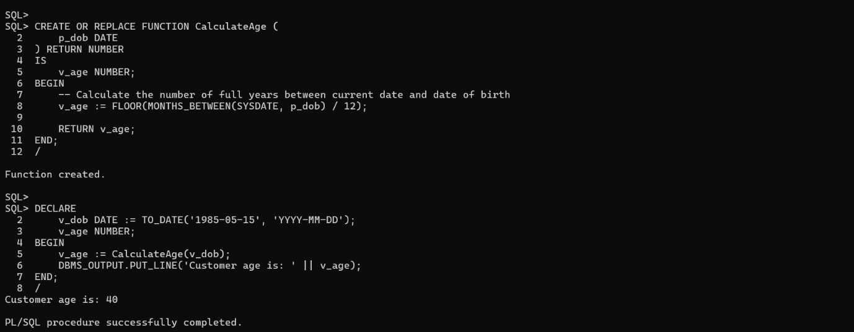

**Scenario 2:** The bank needs to compute the monthly installment for a loan.

**Question:** Write a function **CalculateMonthlyInstallment** that takes the loan amount, interest rate, and loan duration in years as input and returns the monthly installment amount.

CREATE OR REPLACE FUNCTION CalculateMonthlyInstallment (

p_loan_amount IN NUMBER,

p_interest_rate IN NUMBER, -- annual rate in percent

p_years IN NUMBER

) RETURN NUMBER

IS

v_monthly_rate NUMBER;

v_months NUMBER;

v_emi NUMBER;

BEGIN

-- Convert annual interest rate to monthly and percentage to fraction

v_monthly_rate := (p_interest_rate / 100) / 12;

v_months := p_years * 12;

-- EMI formula: [P * R * (1 + R)^N] / [(1 + R)^N - 1]

IF v_monthly_rate = 0 THEN

-- No interest case (simple division)

v_emi := p_loan_amount / v_months;

ELSE

v_emi := (p_loan_amount * v_monthly_rate * POWER(1 + v_monthly_rate, v_months)) /

(POWER(1 + v_monthly_rate, v_months) - 1);

END IF;

RETURN ROUND(v_emi, 2);

END;

/

Output :-

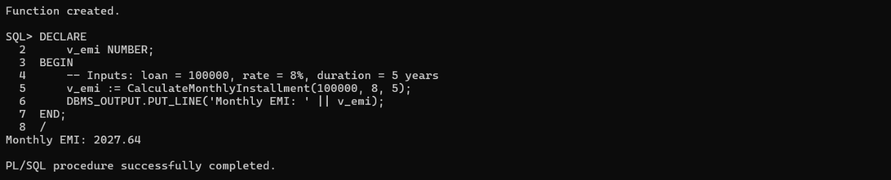

**Scenario 3:** Check if a customer has sufficient balance before making a transaction.

**Question:** Write a function **HasSufficientBalance** that takes an account ID and an amount as input and returns a boolean indicating whether the account has at least the specified amount.

CREATE OR REPLACE FUNCTION HasSufficientBalance (

p_account_id IN NUMBER,

p_amount IN NUMBER

) RETURN BOOLEAN

IS

v_balance NUMBER;

BEGIN

-- Fetch the current balance of the account

SELECT Balance INTO v_balance

FROM Accounts

WHERE AccountID = p_account_id;

-- Return TRUE if balance is sufficient

RETURN v_balance >= p_amount;

EXCEPTION

WHEN NO_DATA_FOUND THEN

DBMS_OUTPUT.PUT_LINE('Account not found.');

RETURN FALSE;

WHEN OTHERS THEN

DBMS_OUTPUT.PUT_LINE('Error: ' || SQLERRM);

RETURN FALSE;

END;

/

DECLARE

v_result BOOLEAN;

BEGIN

v_result := HasSufficientBalance(1, 500);

IF v_result THEN

DBMS_OUTPUT.PUT_LINE('Transaction allowed: Sufficient balance.');

ELSE

DBMS_OUTPUT.PUT_LINE('Transaction denied: Insufficient balance or account not found.');

END IF;

END;

/

**Output :-**

